MS Decom_ZFNAMASS tcode _Changes document

Changes document for MS Decom activities.

Transaction ZFNAMASS /

Program - ZPMDBT_FNA_MASS_CREATE

System: xEM

CD: 152048

Transport request: DEMK931402

---------------------------------------------------------------------------------------------------------------------

1. Modification history logs updated with all the details.

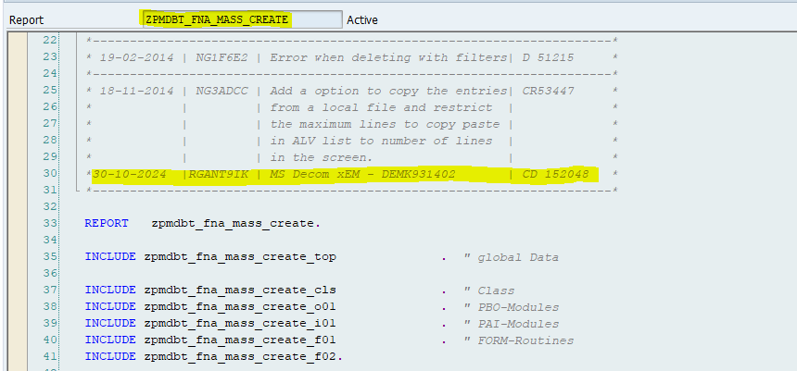

1. Added the new selection screen parameter to pass google sheet url.

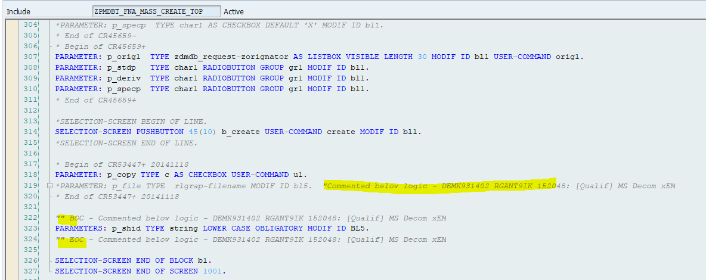

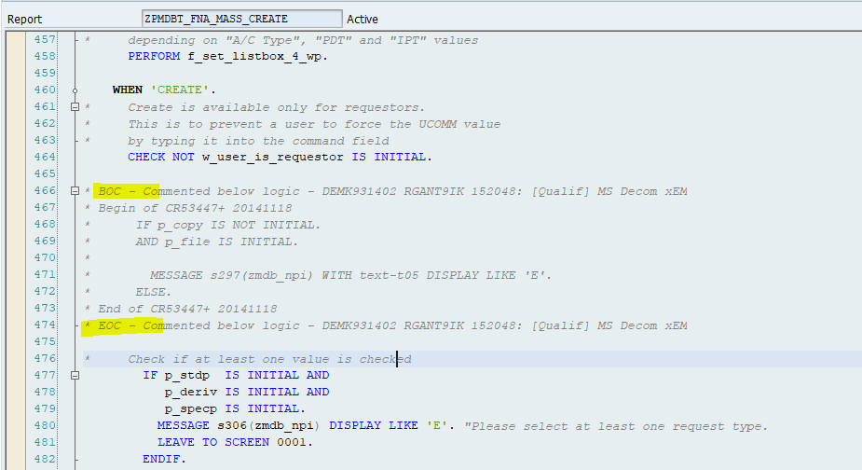

1. Passing the google sheet url instead of the local xlsx file path to read the data.

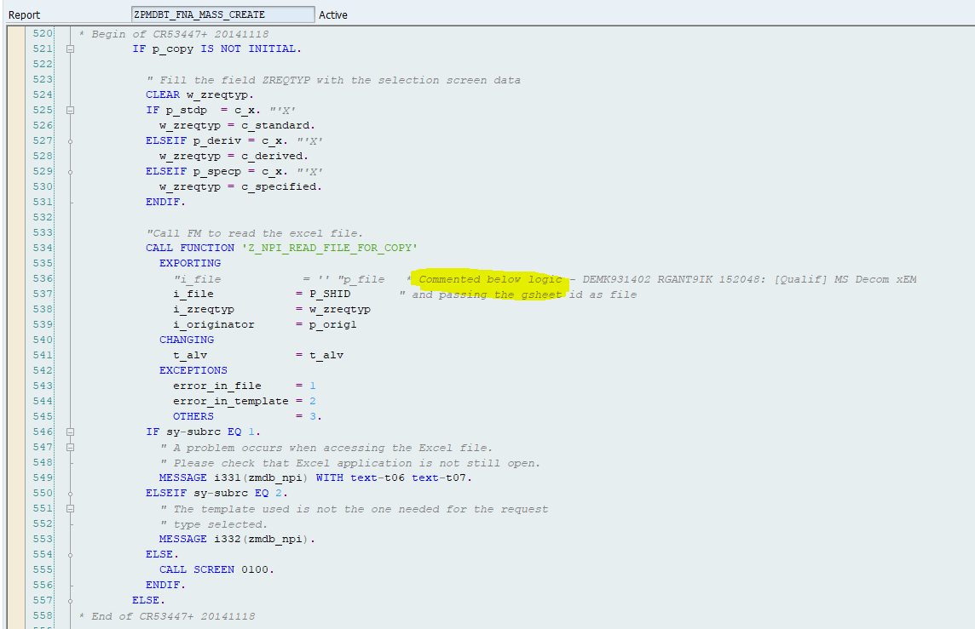

1. Added the modification logs in the FM which is in use to read the file data.

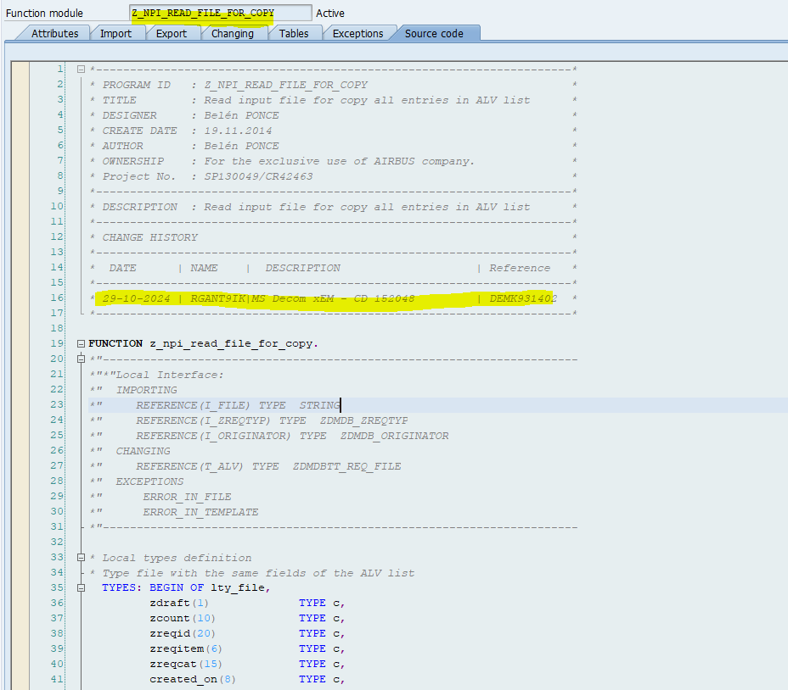

1. Created separate TYPES for all the 3 scenarios - standard, derived and specified to fill the gsheet data into respective fields.

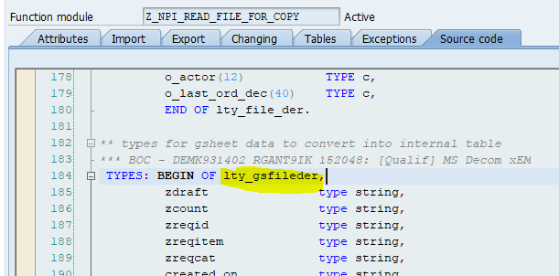

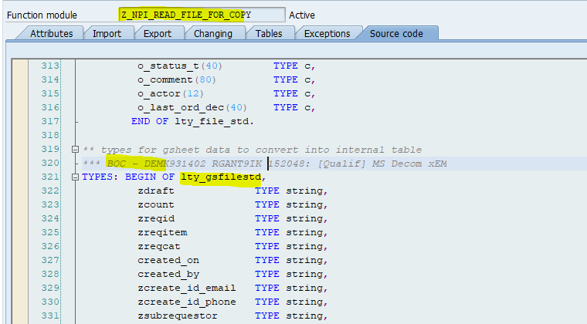

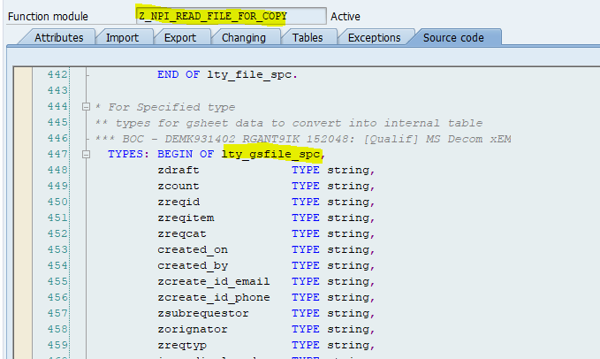

1. Condition to check if the file path is in proper format to read the gsheet.

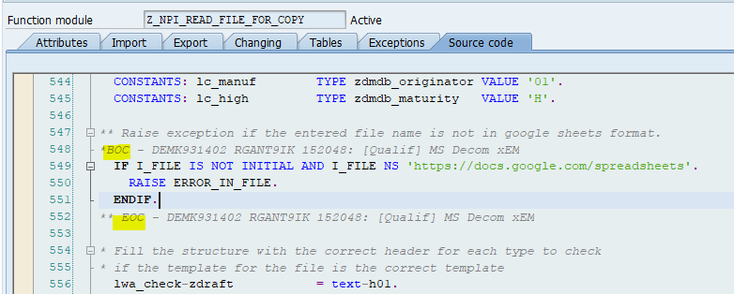

1. Commented the existing xlsx file reading logic and added new logic to read gsheet url and process the data as below.

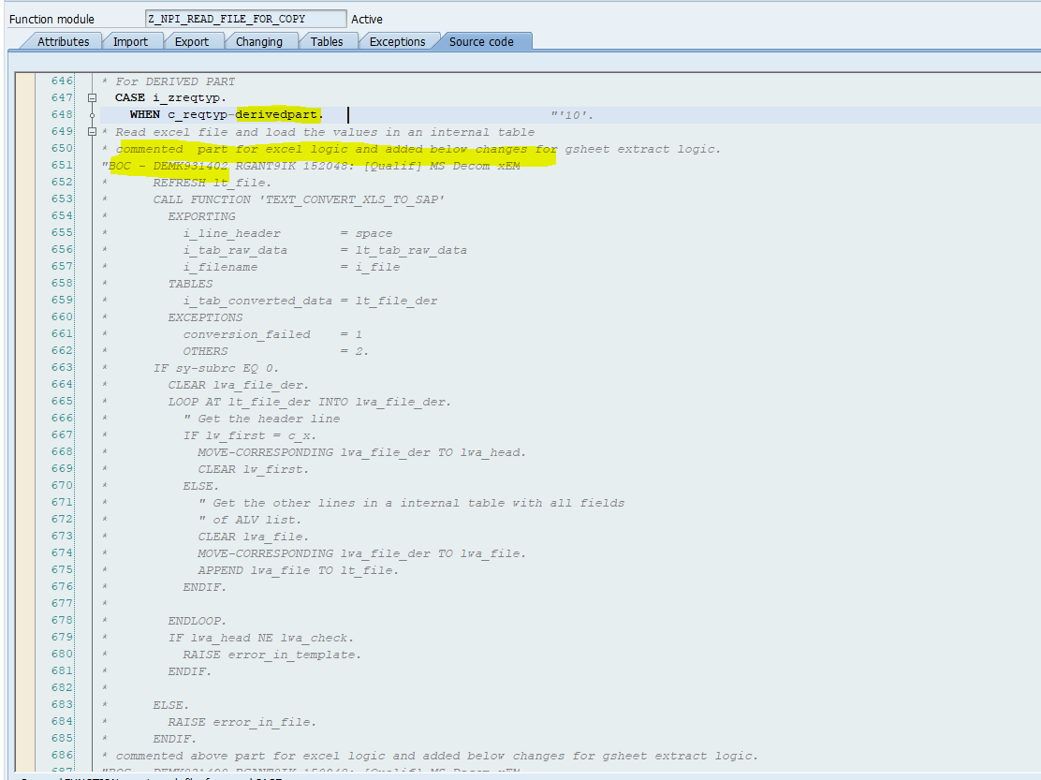

1. Extracting the google sheet data into the respective internal table by using the FM - Z_4B1D_GSHEET2ABAP.

